Name Tag for Safty!

Make a name tag – this is a safty\* issue to help communications.

If you’re wearing layers, put a name tag on each layer so you’ll stay labeled when you take off your top layer.

Write big and bold so your name tag is readable from far away.

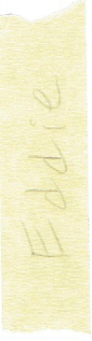

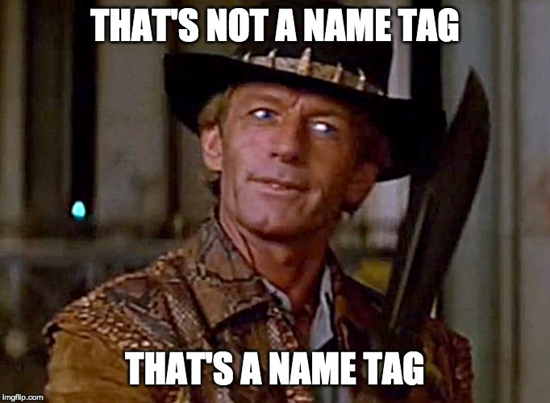

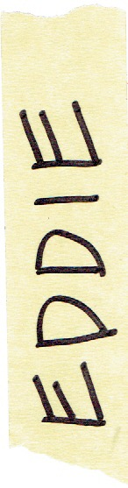

\*Yes, *safty.* Don’t ask. It’s a 997 thing.